# A:\CBHE-factori\aa-starter\Factori_soumis\communication\logo\Logo Factori 4.0.png

# From Automation and Control Training to the Overall Roll-Out of Industry 4.0 Across South-East Asian Nations

# (ASEAN FACTORI 4.0)

**PROJECT No. 609854-EPP-1-2019-1-FR-EPPKA2-CBHE-JP**

**CENTER OF EXCELLENCE**

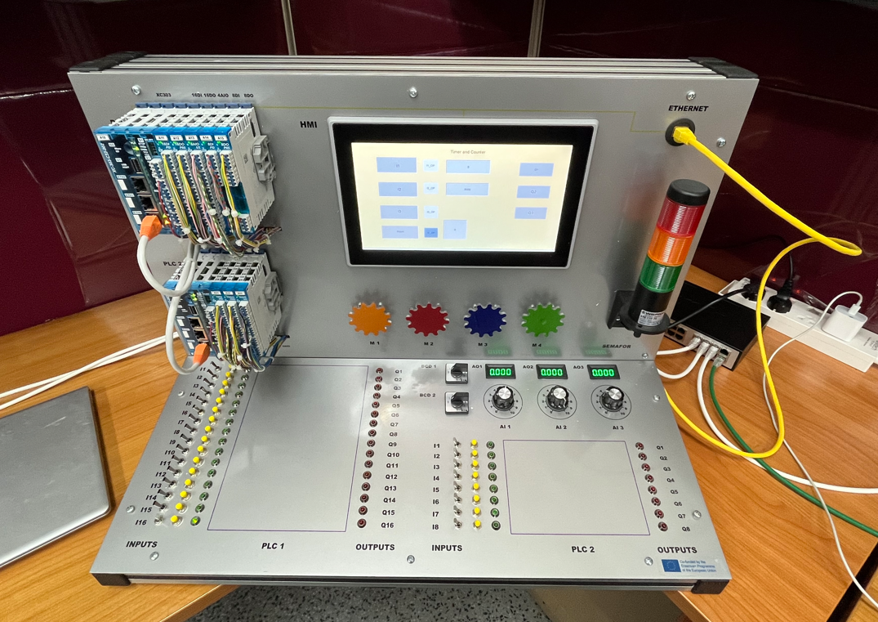

The primary aim of the project is to introduce the subject of manufacturing and processing in partner countries of South-East Asia in order to address growing and emerging demands. This endeavor involves creating pioneering learning labs that leverage industrial Programmable Logic Controllers (PLCs) commonly employed in the automation sector of manufacturing and processing industries. Additionally, the project seeks to establish a Center of Excellence (CE) aimed at enhancing Chulalongkorn University curricula. This initiative particularly targets areas in which education pertaining to this field is currently lacking, spanning both traditional academic and vocational teaching approaches.

The benchmark is located within the Intelligent Control Automation of Process Systems (ICAPS) laboratory, situated on the 4th floor of the Boonrod Binson Building in Room Number 402. This building belongs to the Department of Electrical Engineering. The ICAPS or the Center of Excellence comprises a PLC or a benchmark connected to 4 PC workstations, and 4 computer laptops. This setup facilitates introductory learning experiences for novice students within genuine industrial settings. Moreover, advanced students and industrial collaborators can engage in thesis work centered around PLC subjects. This approach contributes significantly to the project's long-term viability, as the platform's adaptability spans from fundamental teaching to advanced research concept evaluations.

The University of Ruse “Angel Kanchev,” Bulgaria, takes on the responsibility of conducting a benchmark utilizing EATON-MOULLER® PLC. This benchmark is designed to focus on the sequential control of processes. The PLC programs is centered on introducing and exploring the principles of PLC control in automation. The emphasis lies on a comprehensive understanding of using a PLC and its principles. The differentiation between digital and analog input/output configurations, as well as the establishment of input/output connections effectively are explored. The PLC programs will also focus on mastering the ladder programming language (LD), function block diagram (FBD), which are widely used in PLC programming.

Using conventional programming languages such as LD and FBD often results in the creation of lengthy and complex programs that can be difficult to comprehend. As sequential schemes grow in complexity, there's an increasing need for more effective functional description and structuring. To facilitate a more coherent and comprehensive analysis of these schemes, the GRAFCET functional diagram was developed, which has been a European documentation standard (IEC 848) since 1988. Building upon this standard, a high-level PLC programming language named Sequential Functional Diagram (SFC) was formulated.

The objective of this benchmark is to introduce and explore the realm of sequential control in automation, while delving into the application of sequential functional diagrams and GRAFCET diagrams. Additionally, the hands-on experience to become familiar with Human-Machine Interface (HMI) usage, a crucial aspect of modern industrial automation, are also included.

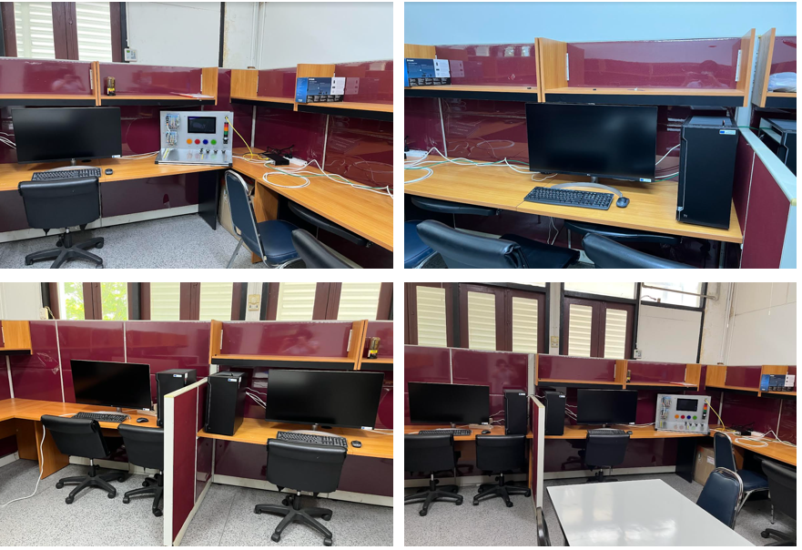

**Picture of Center of Excellence**